**Peer to Peer Loan Analysis**

**Executive Summary**

**- About peer to peer lending**

Peer-to-peer lending, also known as P2P lending, is the practice of [lending](https://en.wikipedia.org/wiki/Loan) money to individuals or businesses through online services. They provide a platform to match lenders with borrowers. P2P lending companies offer online services, so they can run with lower overhead and provide services more cheaply than traditional financial institution like banks. Hence, lenders can earn higher returns compared to savings and investment options given by banks and borrowers can borrow money at lower interest rates, even after being charged a fee by the lending company for providing the [platform](https://en.wikipedia.org/wiki/Computing_platform) and [credit checking](https://en.wikipedia.org/wiki/Credit_check) the borrower. A downside to such a platform is that there is an inherent risk of the borrower defaulting on the loans taken out from such peer-lending websites. [1]

**- About Lending Club**

Lending Club is one such [peer-to-peer lending](https://en.wikipedia.org/wiki/Peer-to-peer_lending) company, headquartered in [San Francisco, California](https://en.wikipedia.org/wiki/San_Francisco,_California). They are first such lender to register their offerings as [securities](https://en.wikipedia.org/wiki/Security_(finance)) with the Securities [and Exchange Commission](https://en.wikipedia.org/wiki/U.S._Securities_and_Exchange_Commission) (SEC), and to offer loan trading on a secondary market. They enable borrowers to create [unsecured personal loans](https://en.wikipedia.org/wiki/Unsecured_debt) and standard loan period is three years. Investors can search and browse the loan listings on Lending Club website and select loans that they want to invest in based on the information supplied about the borrower, amount of loan, loan grade, and loan purpose. Investors make money from interest. Lending Club makes money by charging borrowers an origination fee and investors a service fee. [2]

**Loan Characteristics**

**- Distribution of Loan Term**

|  |  |
| --- | --- |
| Terms | Frequency of Loans (%) |
| 36-Month | 70.25407 |
| 60-Month | 29.74593 |
| Total | 100 |
|  |  |

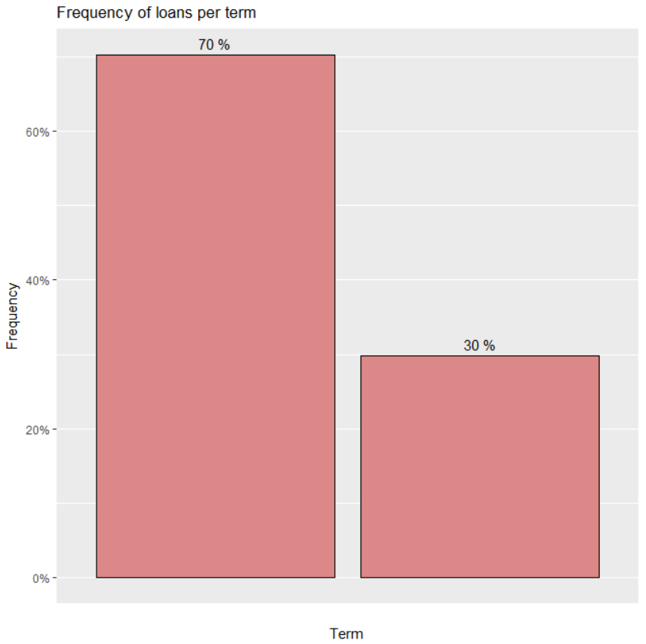

**- Distribution of Loan Grade**

Grades and frequency of loans (%)



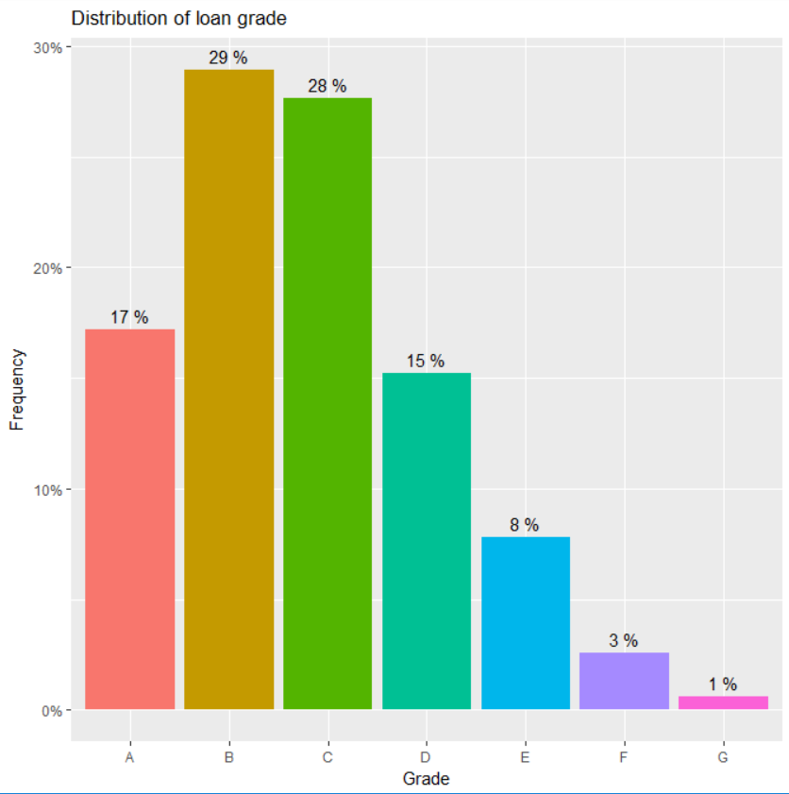

**- Frequency of Loans for a quarter for a grade for each year-**

Frequency of loans in Q3 and Q4 are more for almost all grades than in Q1 and Q2 from issue year 2012 to 2015. Also, number of loans in grade B and C are greater than that of other grades since 2012.

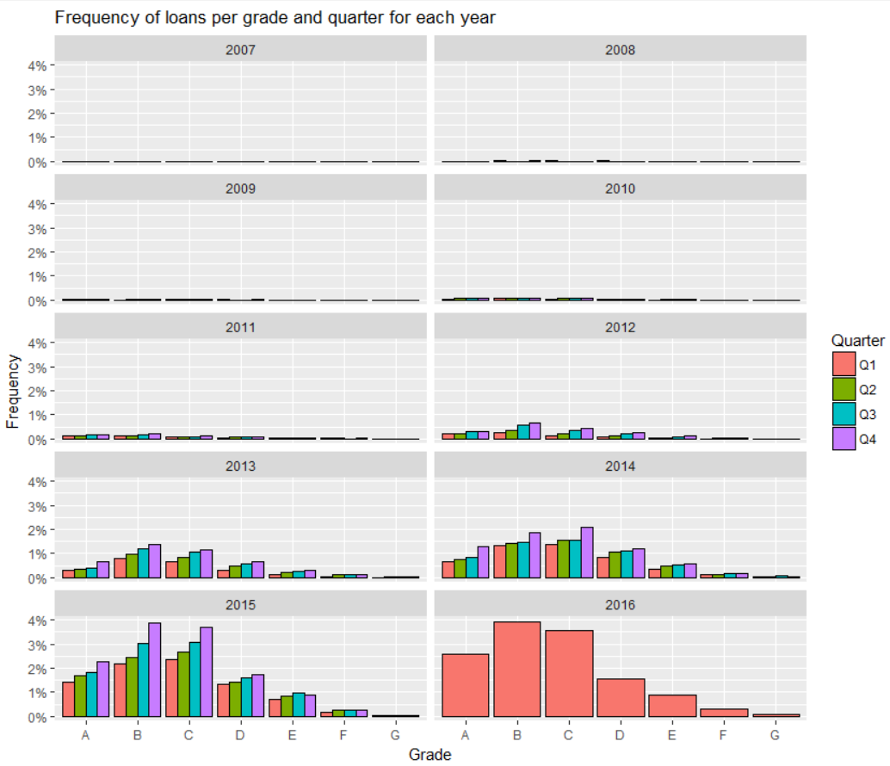

**- Distribution of FICO Score**

**Frequency of of mid application fico, mid last fico and mid change in fico:**

Frequency of application fico band is highly positively skewed and most the bands lie between 670 to 700.

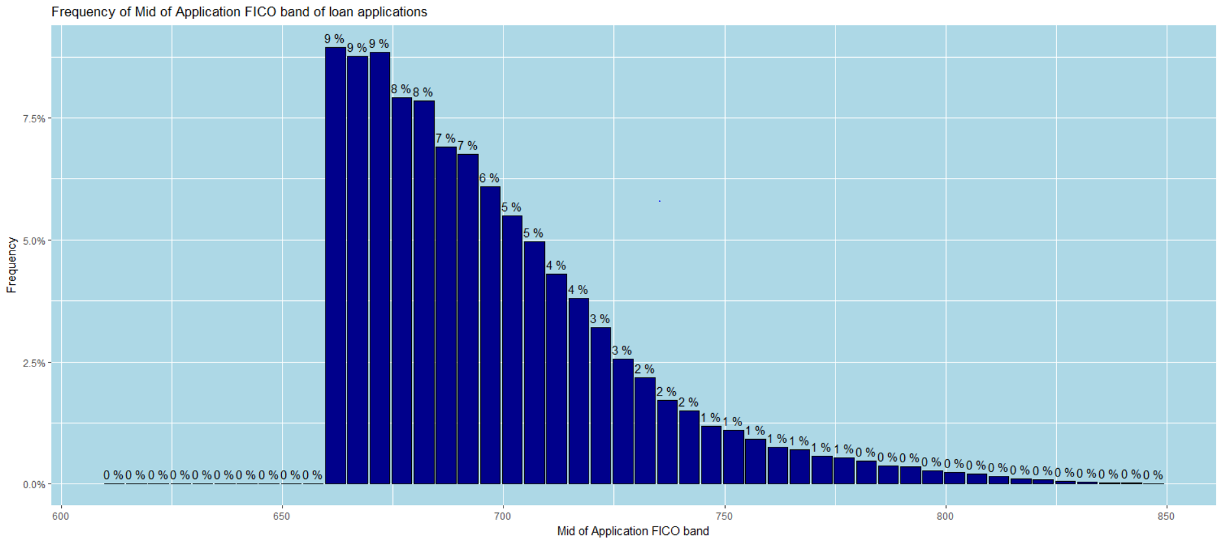

Frequency of last fico band is more or less normally distributed from the mid last fico range 550 to 850 except there is a considerable amount of loans having last fico value lesser than 500.

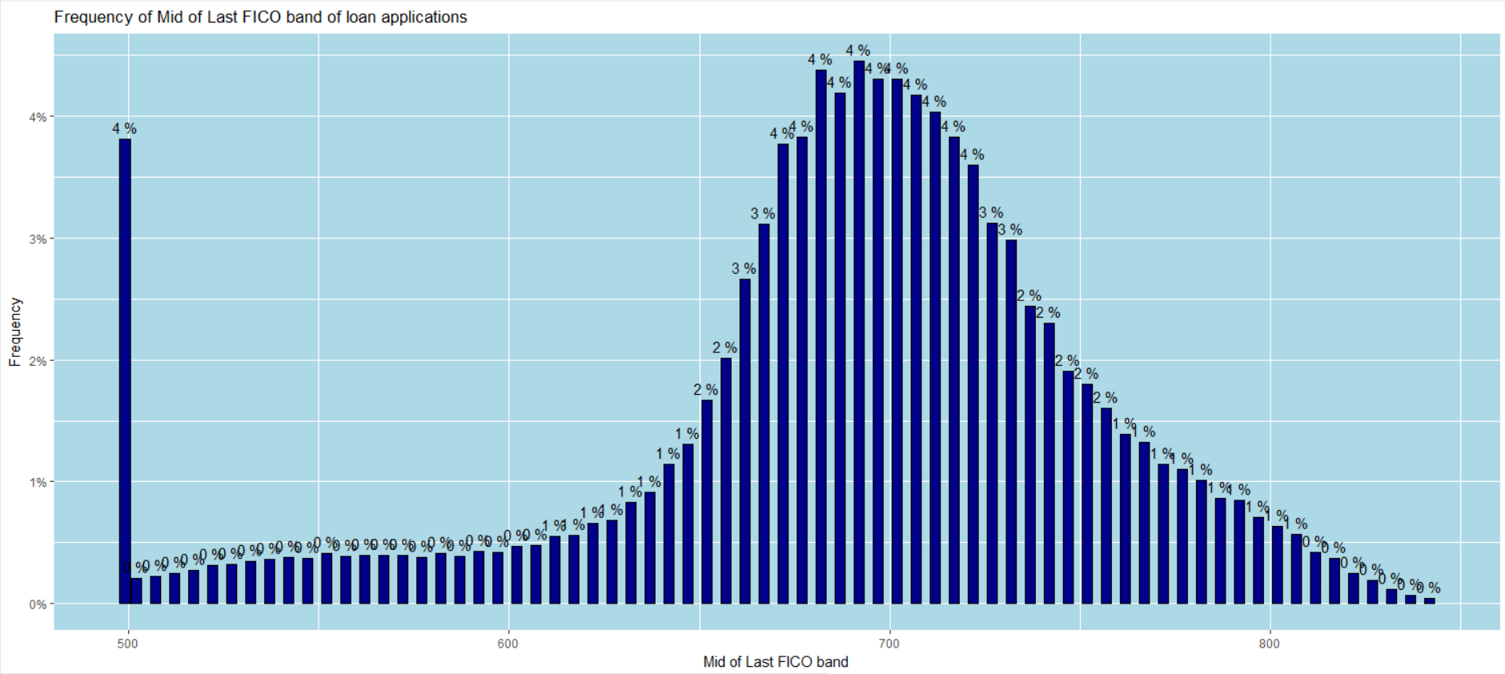

Frequency of change in fico band plot shows there has not been much modification between the application and last fico bands with most of the band change are values between +/- 50.

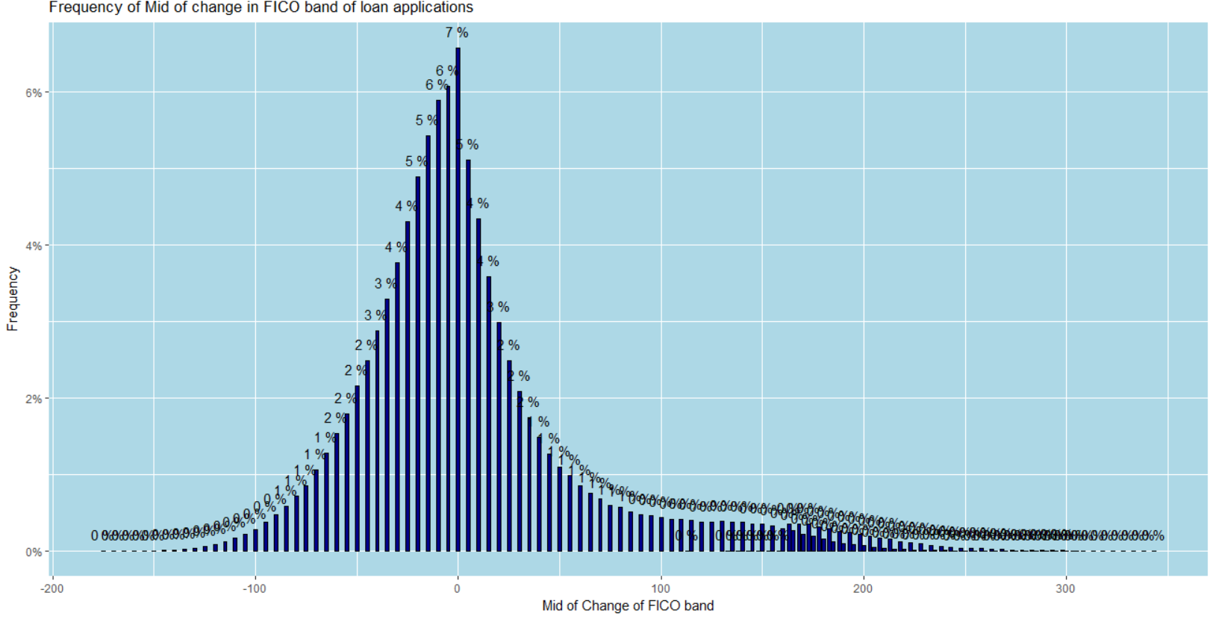

**- Distribution of DTI**

**Frequency plot for DTI bands:**

**Summary of DTI:**



**DTI Band Frequency**

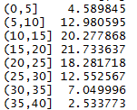

Plot shows DTI values range mostly between 10 to 25 for the loan applications.

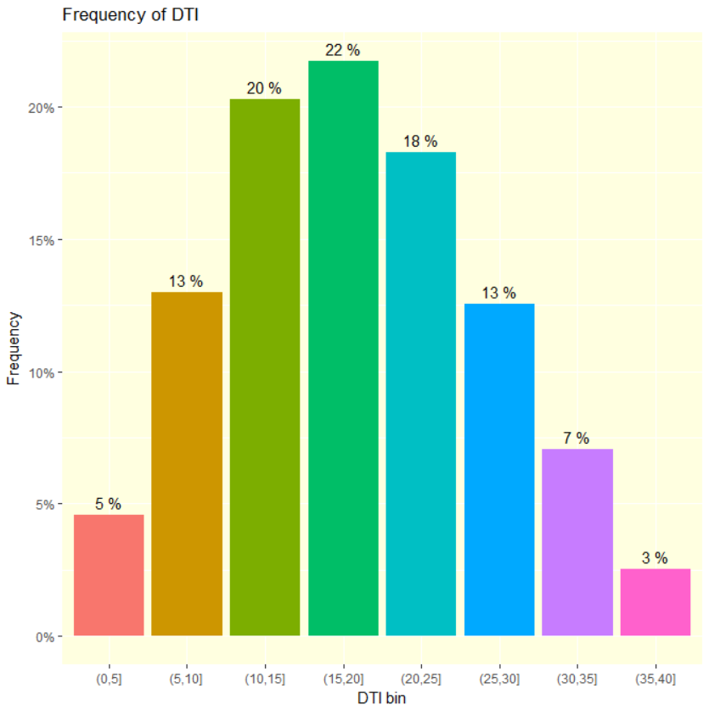

**- Distribution of Home Ownership**

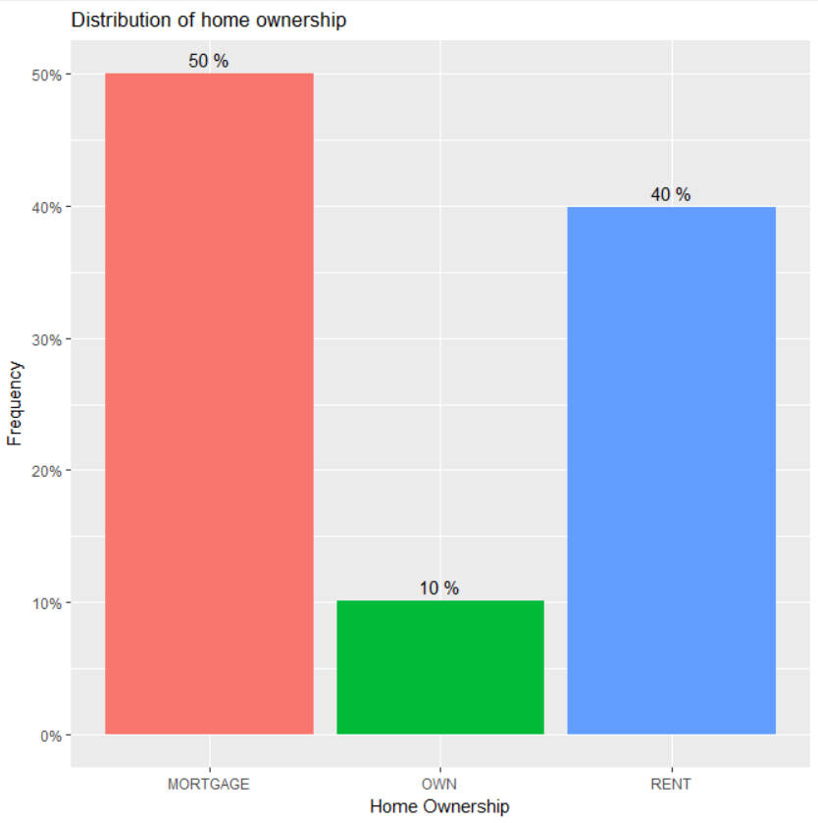

**- Boxplot of funded amount for every issue year**

Mean funded amount has been consistently increasing from 2007 to 2008 to 2009, then remained more or less same in 2010 but again increased in subsequent years 2011,2012,2013. There is not much change in the mean funded amount from 2013 to 2014 but an increase in 2015 and 2016. Plot also shows the amount of funds increased significantly from 2010 to 2011 and 2015 to 2016.

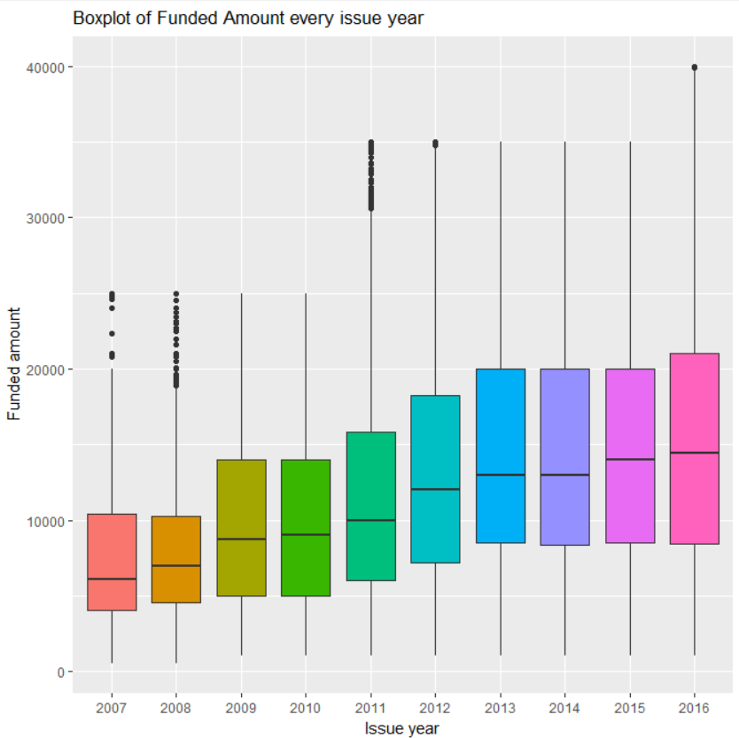

**- Mean interest rate for each term**

Mean interest rate for 60 months term loans are higher than that of 36 months term.

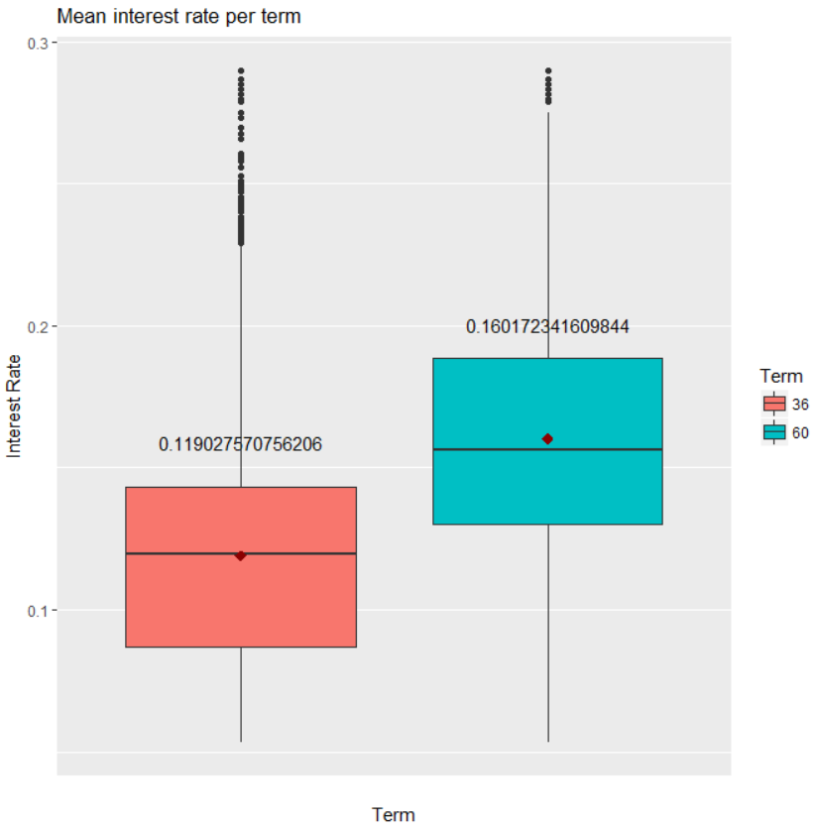

**- Scatter plot of Monthly Income V/S Interest Rate with grade allocated to the loan**

Limiting the monthly income between 0 to 20000 to avoid outliers and plotting a scatter plot between monthly income and interest rate shows interest rates generally decrease for higher incomes. Also, interest rates increase from loan grade order A to G.

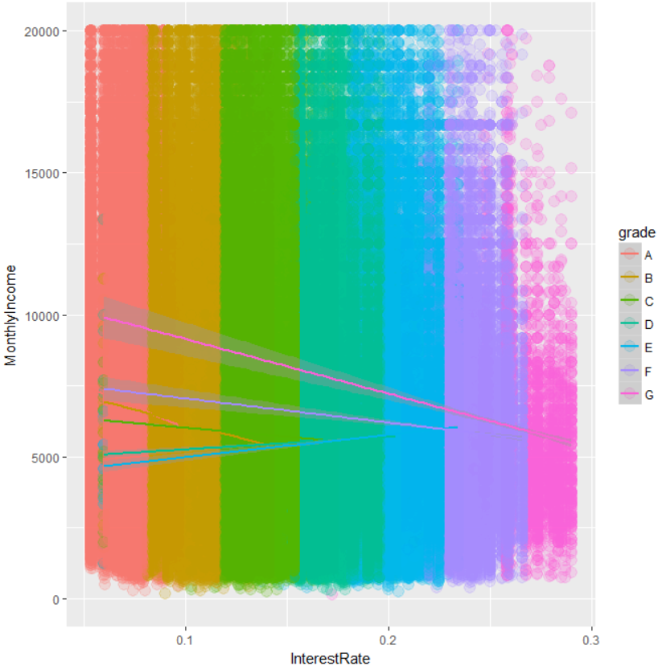

**Multi-attribute Characteristics**

**- Loan Amount for different Years, Grade, and Term**

**Term 36 months:**

Weighted average loan amounts for every grade have been fluctuating since each issue year but seem to be more or less stable in 2015 and 2016. In 2016, weighted average loan amounts are highest for grade A around 15000, between 13000 to 12000 in order for grades D, C, B, E and lower for grades F and G around 10000.

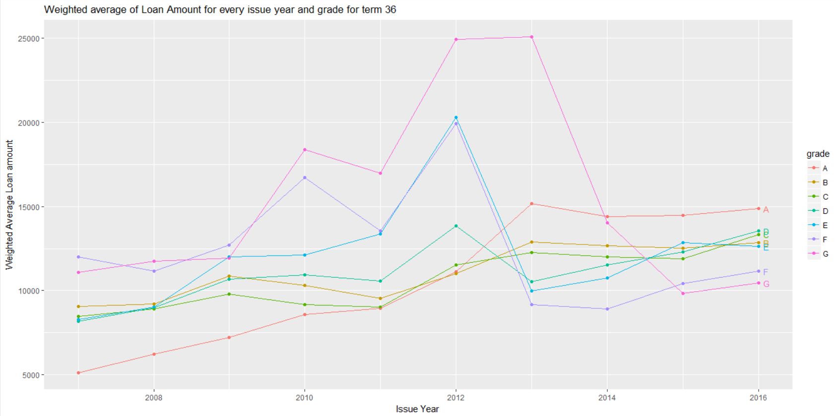

**Term 60 months:**

Weighted average loan amounts for every grade have been fluctuating since each issue year but seem to be more or less stable since 2013. In 2016, weighted average loan amounts are between 23000 to 20000 in order for grades F, G, E, B, D, A and C.

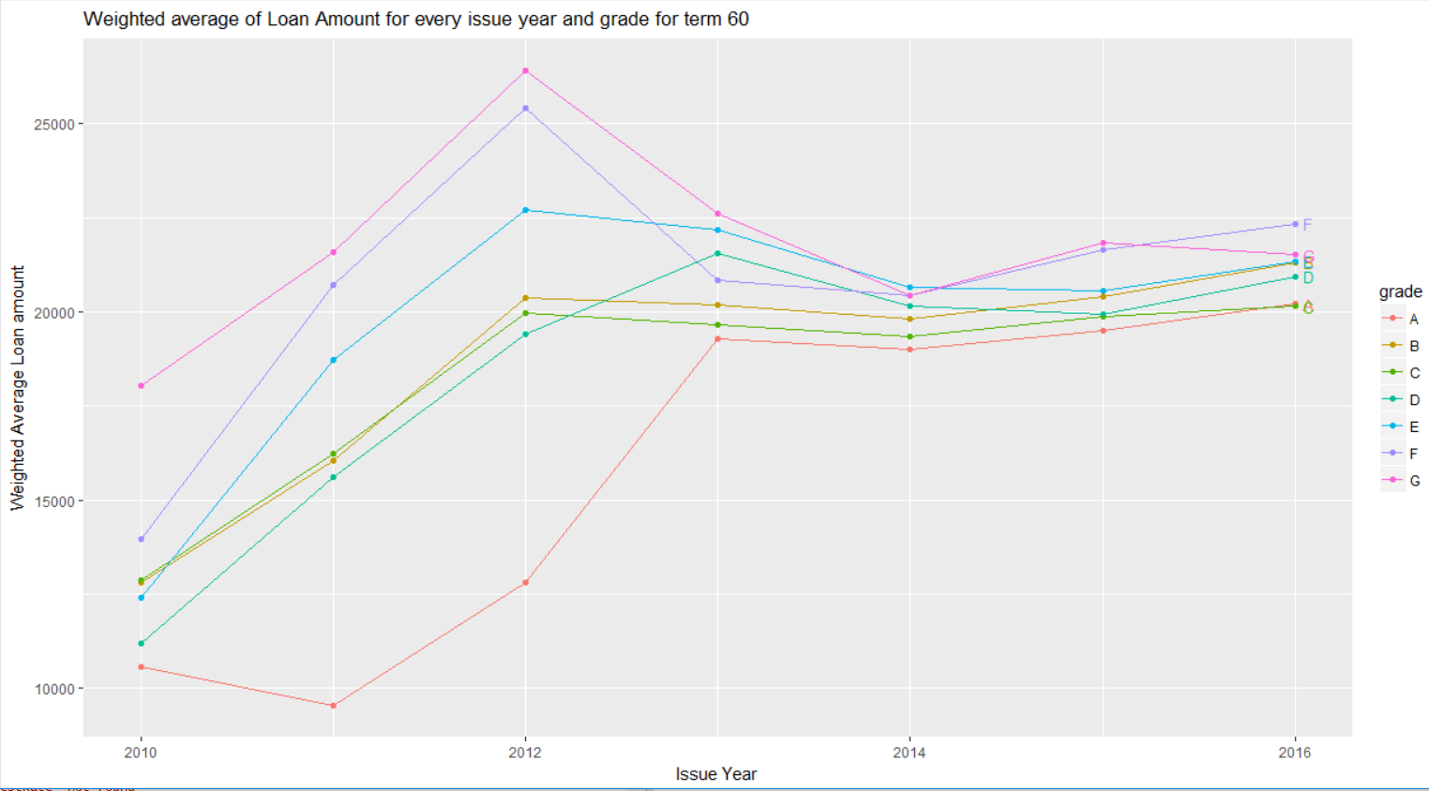

**- Interest Rate for different Years, Grade, and Term**

**Term 36 months:**

Weighted average Interest Rate for every grade has been generally increasing each issue year. In year 2016, the average interest rates are highest to lowest for grades in order of G, F, E, D, C, B, A.

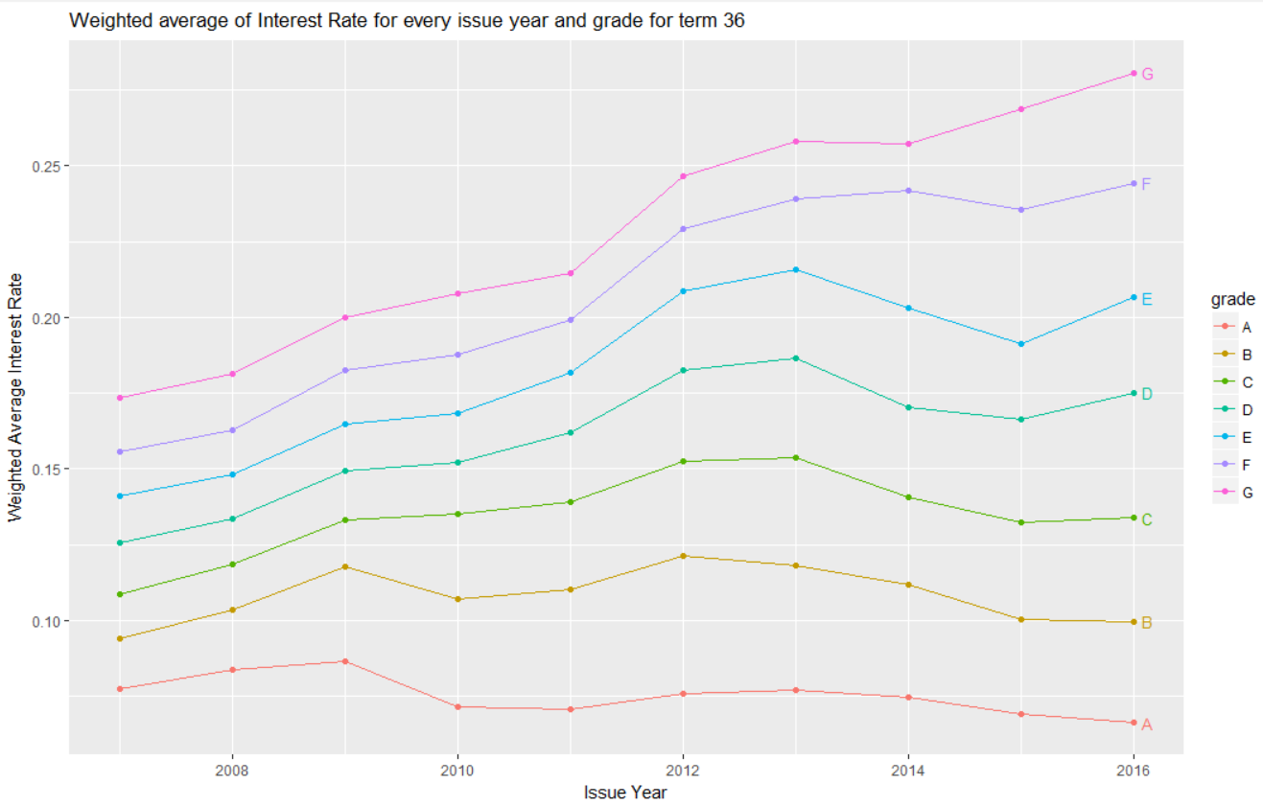

**Term 60 months:**

Weighted average Interest Rate for every grade has been generally increasing each issue year. In year 2016, the average interest rates are highest to lowest for grades in order of G, F, E, D, C, B, A.

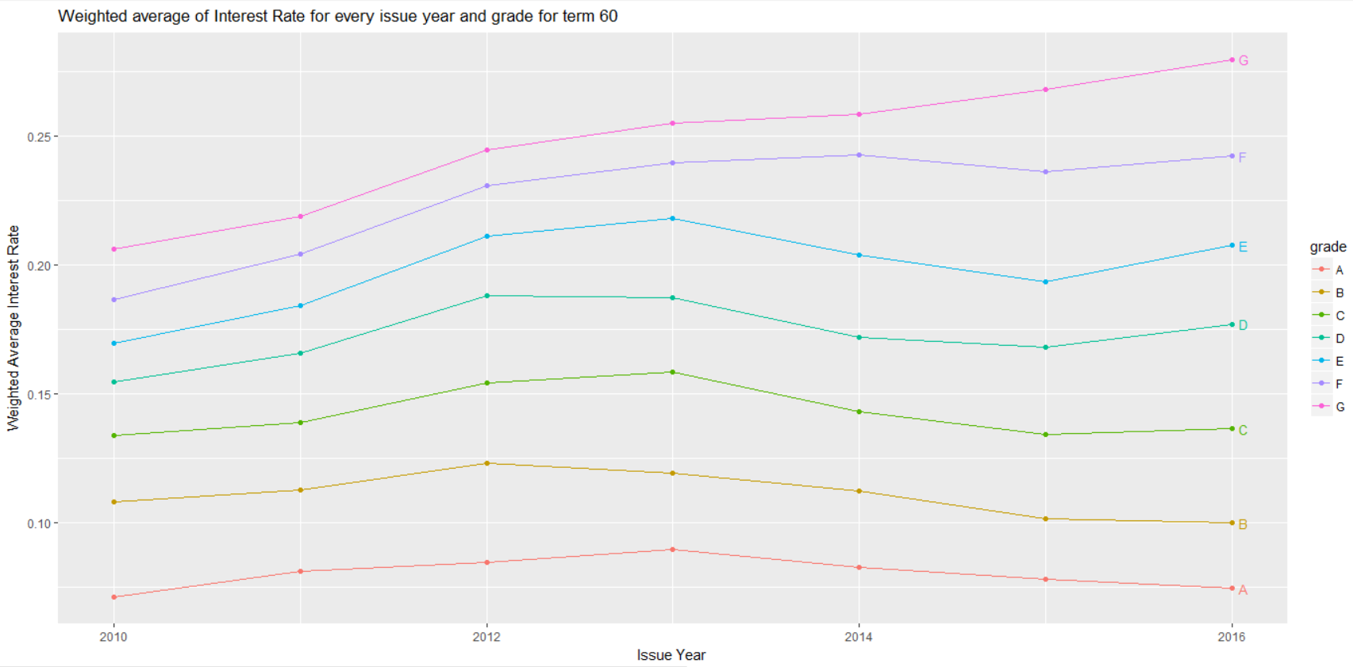

**- Charged off Rate for different Year, Grade, and Term**

Combining Charged Off and Default loans to find the rates for different year, grade and term.

**Term 36 months:**

Charged Off/ Default loans rate are generally higher for grades B, C and D in each issue year for 36 months term loans.

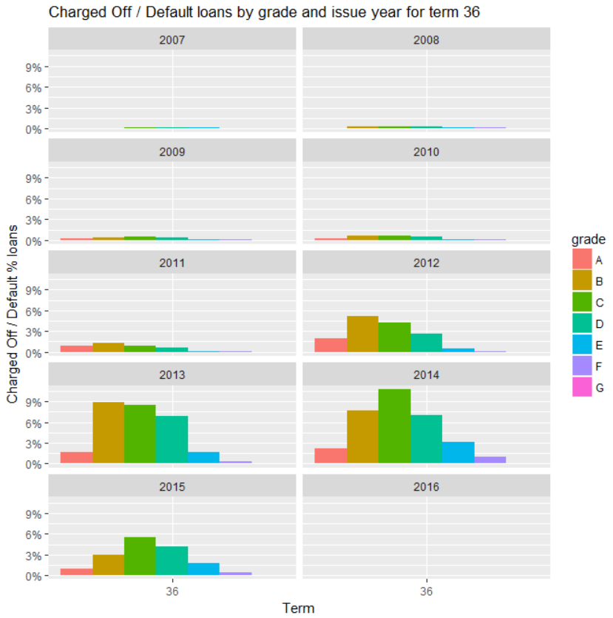

**Term 60 months:**

Charged Off/ Default loans rate are generally higher for grades C, D, E and F in each issue year for 60 months term loans.

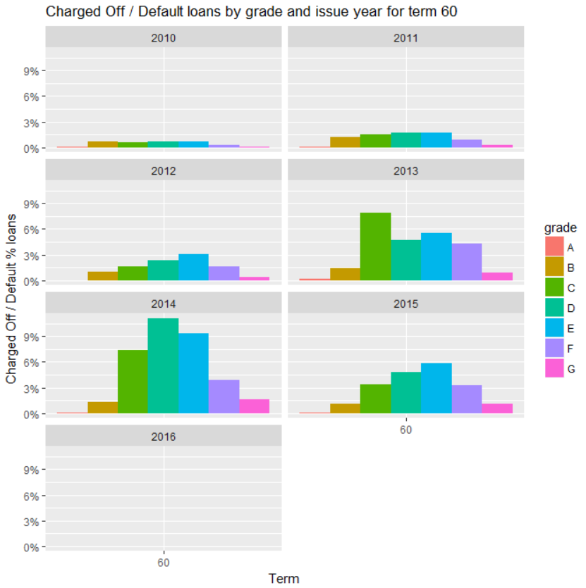

**- Prepayment Rate for different Year, Grade, and Term**

Fully paid loans that were paid back before their term end are categorised as Prepaid.

**Term 36 months:**

Prepayment loans rate are generally higher for grades A, B and C in each issue year for 36 months term loans.

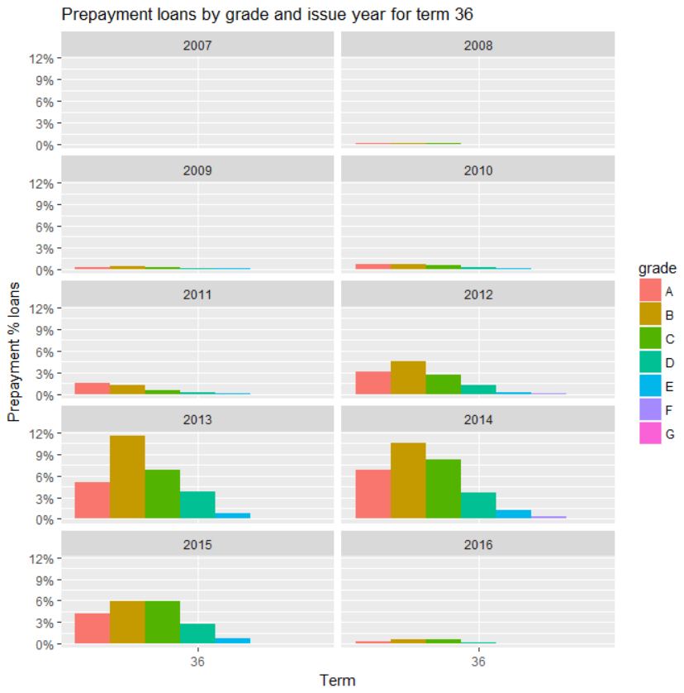

**Term 60 months:**

Prepayment loans rate are generally higher for grades C, D and E in each issue year for 60 months term loans.

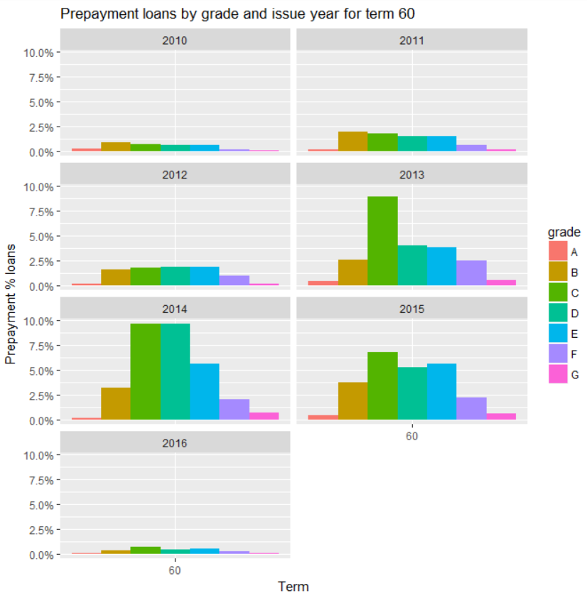

**- Cumulative Charged-Off Rate for different Year, Grade, and Term**

**Term 36 months:**

Plot shows the net cumulative % charged off loans are highest for year 2007, followed by 2008, 2009, 2012, 2010, 2011, 2013, 2014, 2015 and 2016.

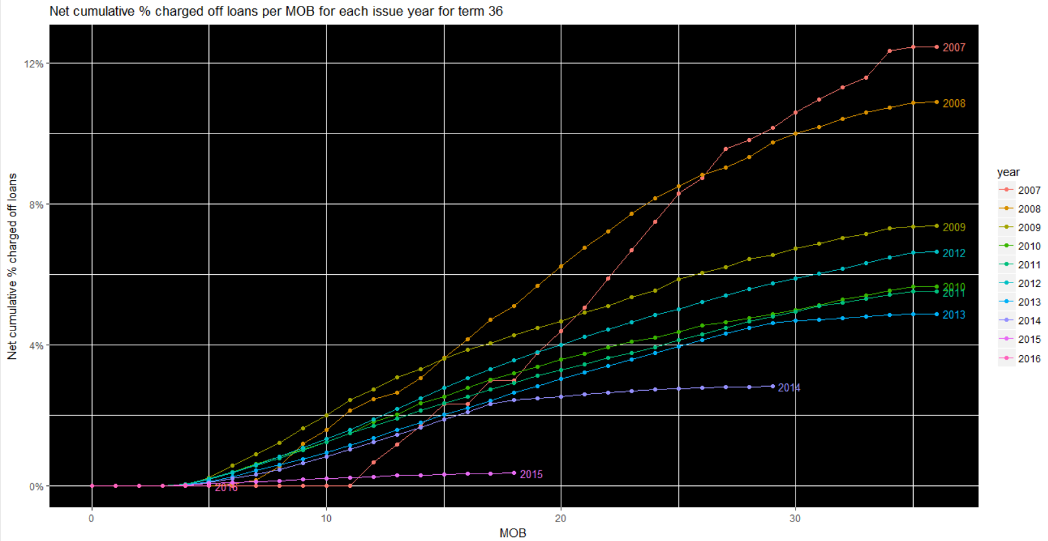

**Term 60 months:**

Plot shows the net cumulative % charged off loans are highest for year 2010, followed by 2011, 2012, 2013, 2014, 2015 and 2016. The loans on month on book also decrease in the same order.

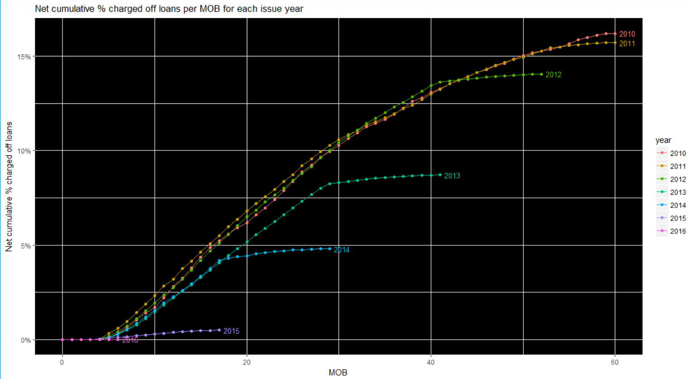

**Predictive Models**

**- Summary of Grade A logistic regression model**

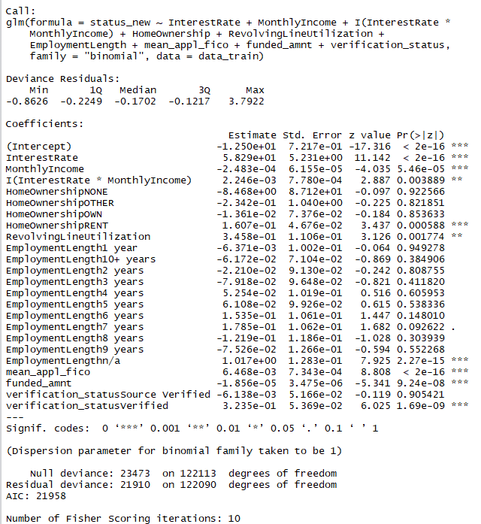

Cut-off for classification is chosen such as the false omission rate (error rate) i.e. the misclassification of good loans is minimised.

Summary of top 10% loans classified as good/profitable after fitting the model gives a max Interest Rate for borrower of 9.25% and Return of 8.68% for lender.

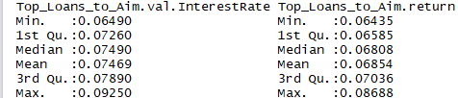

**- Summary of Grade B logistic regression model**

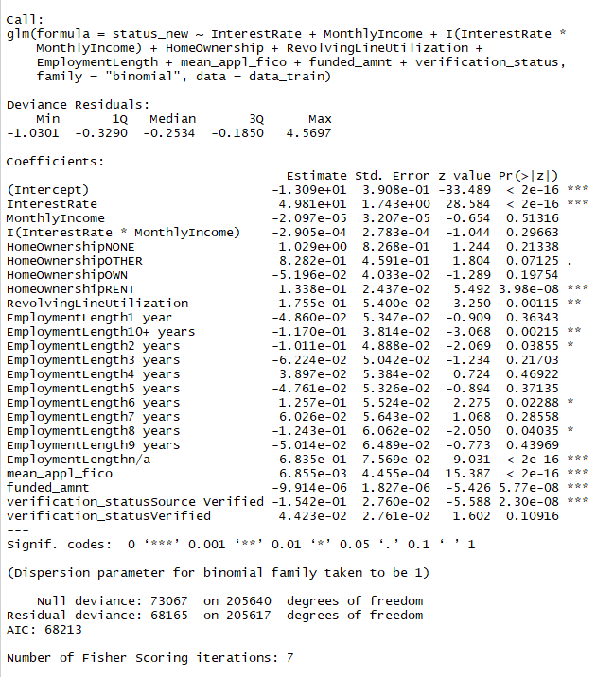

Cut-off for classification is chosen such as the false omission rate (error rate) i.e. the misclassification of good loans is minimised.

Summary of top 10% loans classified as good/profitable after fitting the model gives a max Interest Rate for borrower of 13.67% and Return of 13.56% for lender.

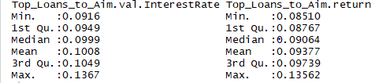

**- Summary of Grade C logistic regression model**

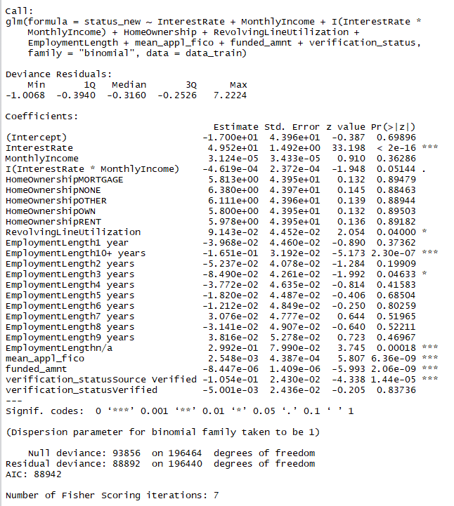

Cut-off for classification is chosen such as the false omission rate (error rate) i.e. the misclassification of good loans is minimised.

Summary of top 10% loans classified as good/profitable after fitting the model gives a max Interest Rate for borrower of 17.27% and Return of 17.06% for lender.

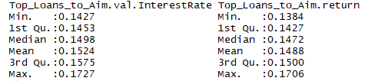

**- Summary of Grade D logistic regression model**

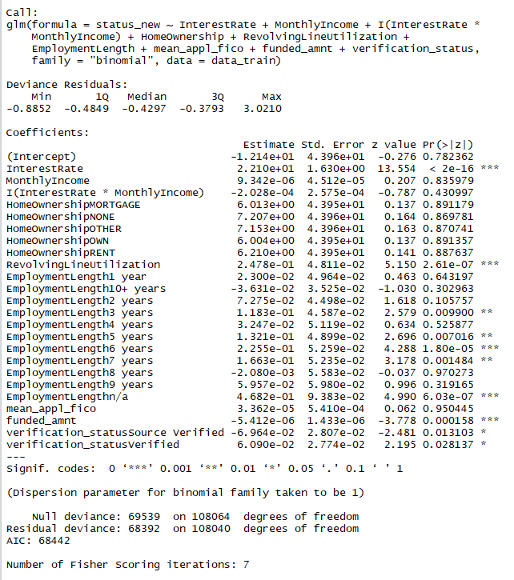

Cut-off for classification is chosen such as the false omission rate (error rate) i.e. the misclassification of good loans is minimised.

Summary of top 10% loans classified as good/profitable after fitting the model gives a max Interest Rate for borrower of 19.47% and Return of 18.87% for lender.

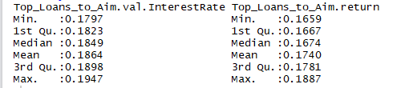

**- Summary of Grade E logistic regression model**

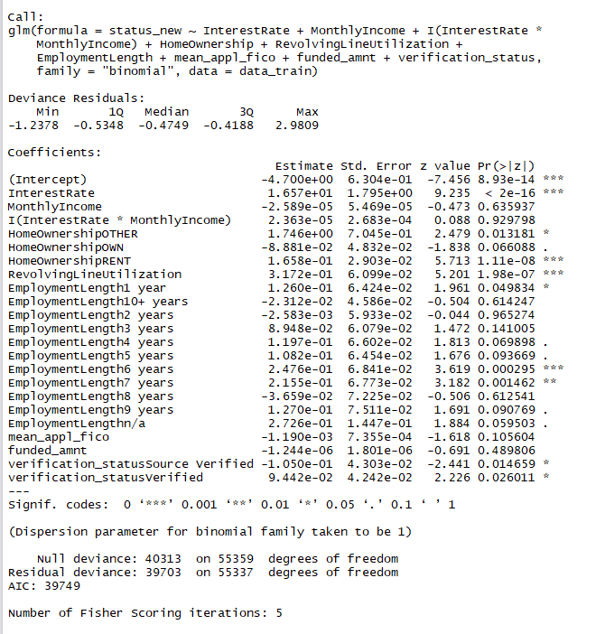

Cut-off for classification is chosen such as the false omission rate (error rate) i.e. the misclassification of good loans is minimised.

Summary of top 10% loans classified as good/profitable after fitting the model gives a max Interest Rate for borrower of almost 20% and Return of 18.78% for lender.

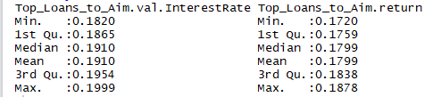

**- Summary of Grade F and G logistic regression model**

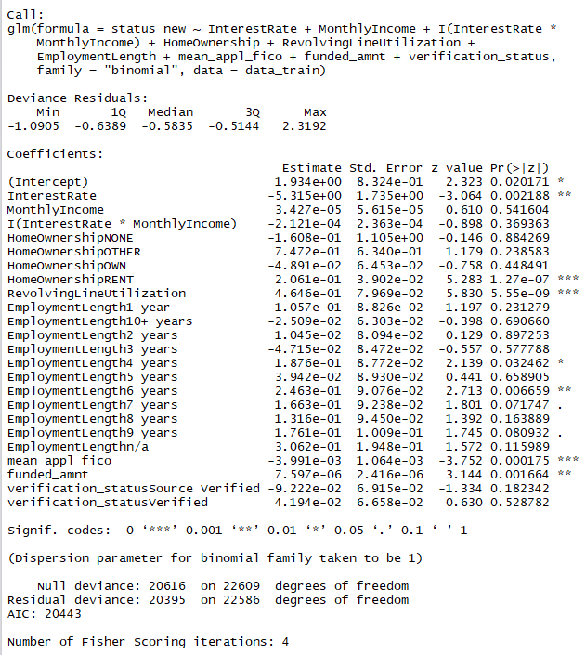

Cut-off for classification is chosen such as the false omission rate (error rate) i.e. the misclassification of good loans is minimised.

Summary of top 10% loans classified as good/profitable after fitting the model gives a max Interest Rate for borrower of almost 29% and Return of 20.78% for lender.

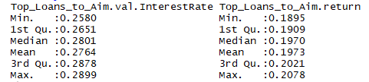

**- ROC curves of each logistic regression model**

ROC curves for grade A, B, C, D, E, F&G models are represented by red, blue, black, green, yellow, purple lines respectively in the plot.

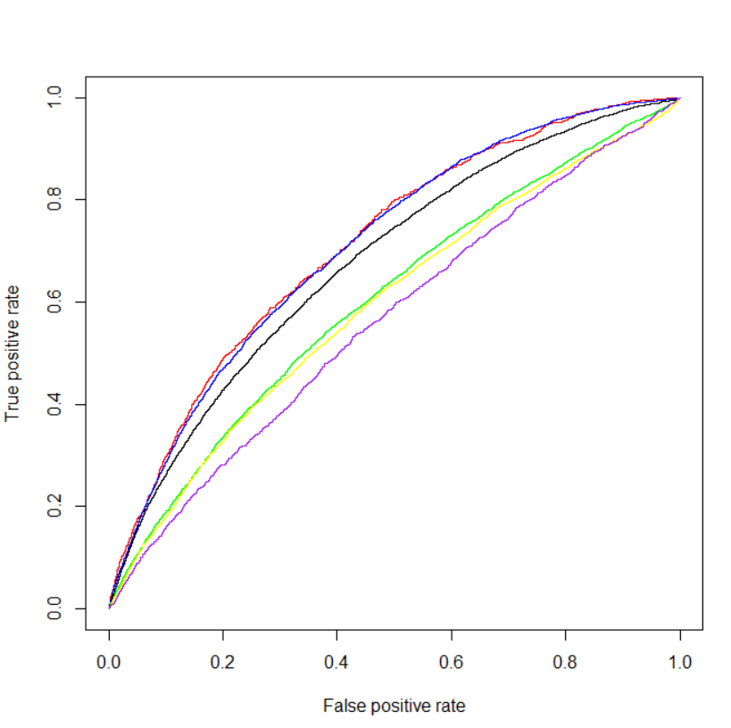

Area under the curve for each model:

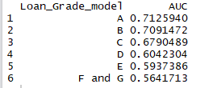

Model A has highest area under the curve amongst all the models and performs the best in comparison to other models followed by B, C, D, E then F&G.

**References-**

1. "Peer to peer lending." Wikipedia. Wikipedia Foundation, 21 June 2017.

<https://en.wikipedia.org/wiki/Peer-to-peer_lending>

1. "Lending club." Wikipedia. Wikipedia Foundation, 21 June 2017.

https://en.wikipedia.org/wiki/Lending_Club